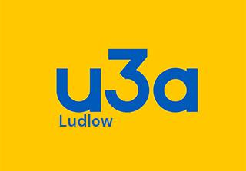

ANNUAL GENERAL MEETING

The Annual General Meeting of Ludlow u3a will be held in the Assembly Rooms in Ludlow
at 10:30am on Monday 25th March 2024

A G E N D A

- Apologies for absence
- Minutes of the last AGM and any matters arising
- Chair’s Report for 2023
- Treasurer’s Report for 2023
- Election of Officers and Committee members
- Election of Examiner
- Any other business

